Sruthi Sundaram
Genre Analysis essay
Intermediate Composition
10/18/2013
Documenting Research: Formal and Informal
All scientific research is conducted through a single process, the scientific method. Through hypothesis testing, experimentation, and analysis, researchers arrive at conclusions based on their work. Once a conclusion is formed, the results are documented, most often in the form of posters or journal articles, and are then reviewed, printed in scientific journals, and added to a database containing all the information that any researcher can use for his own project. Every individual procedure contributes to the individual researcher’s project, which contributes to that researcher’s lab, whose ultimate project adds to the plethora of academia present on that subject. Much of this information is used in other labs to contribute to a subunit of those labs and finally to another individual researcher’s project down to the individual procedures he conducts. This cycle is in continuous motion in research communities and builds up an archive of information that can be studied by members of these communities. However, before experiments can be formally documented—a process which often involves collaborative efforts between several researchers—the individual’s project must be considered. The texts utilized by the lab can reflect either the individual project or the larger purpose of the lab, depending on the way in which they are used.
I work in a lab with the UC Chemistry department. The purpose of our lab is to analyze the binding properties of the eukaryotic protein, lysyl-tRNA synthetase (LysRS) with tRNA^{lys}. The binding of protein to nucleic acid is a very important research topic because it is involved in the reverse transcription of HIV into cells. If an HIV virion cannot incorporate itself into a cell, it can neither replicate effectively nor affect the cell. In fact, preventing the binding of protein to RNA may very well be the final answer to this horrific immunosuppressive disease that the world has been searching for, for so long. It is a noble goal, no doubt, but truly has very little to do with any of the work that I contribute to the lab.
My personal contribution is best represented by my lab notebook. Every one of us has our own individual notebooks, and we use these notebooks to keep track of our own individual project. Since this semester is my first semester of actually doing research, as I was a shadower previously in the spring, I do not yet have my own personal project. Consequently, my notebook reflects mainly what those senior to me have taught me. The lab notebook falls under the genre of informal research documentation and has a simple structure. I write down the date when I come in to lab each day, and all of my notes are documented under that date. One of the most important components of my lab notebook is protocols for all the procedures I perform as well as those I witness others perform. Under the heading for these protocols, I specifically state who performed the experiment. For instance the protocol for SDS PAGE does not have a name associated with it, which means that I personally performed the experiment. However, the protocol for the RNase alert test has my senior undergraduate mentor’s name in brackets, which means that he conducted the experiment (Sundaram 2-6, 26). This is especially useful to my professor as it notifies her of which procedures I have actually performed and which ones she still has to teach me.
Since many of the biochemical procedures I perform are complex, the notebook is very important to me as I refer to it often to make sure I am using the right formula and conducting each step of the experiment correctly. This aspect of my notebook is also useful to others. Oftentimes, my professor will ask me to check in my notebook for specific instructions for parts of procedures she performs. My lab notebook also measures the effectiveness of the procedures I perform. By sequentially ordering my work, I can compare the results of a procedure I performed twice using the scientific method. If the procedure does not work, I have to analyze all the possible instances where it could have failed, hypothesize which part is the culprit, experiment with modifications, and analyze those results. Two specific instances that demonstrate this both involve the Electromobility Shift Assay (EMSA), a procedure that allows us to visualize the binding of protein to RNA on a gel. The EMSA I performed on a sample on 10/4/2013 did not produce very clear results when I photographed it. However, because of my notebook, I had all the protein concentrations and dilution information recorded, so when I conducted the experiment again, I was able to refer to the precise concentrations to which all of my samples needed to be diluted. I determined that the first time I conducted the experiment, I had not properly measured the dilutions for the reaction mixtures, so I repeated the procedure with much clearer results (Sundaram 27, 29, 33). The other instance was my analysis of the EMSA protocol, which I was able to experimentally improve. The textbook protocol used 5X TB buffer for the gel. However, I found that 5X TB buffer precipitated too easily in solution, so I modified the formula amounts to use 1X TB buffer. While this modification was more effective, it caused us a greater cost in the amount of TB buffer we had to continuously make because one gel now required five times as much 1X TB buffer as originally needed with the 5X. So my professor suggested that I form a compromise between the two and make 2.5X buffer instead. With the second modification, even though I do use more 2.5X than 5X for each gel, the amount is small enough that one stock of the buffer will last the lab for a decent number of gels (Sundaram 24, 28). This modification may come in useful for others in my lab, both presently and in the future, as it is more effective than the original formula we used previously.
I received my own lab notebook at the beginning of this semester as a token of my ascent from a shadower to a researcher. Since I do not have my own project, my current individual purpose in the lab is to conduct biochemical procedures for my professor’s work. My lab notebook reflects this; there is no particular organization to the experiments I perform because they are very dependent on what my professor happens to be doing that day. However, I do treat each individual procedure as a project of its own and apply the scientific method to each of them, properly documenting the results, analyzing them, forming hypotheses for further experimentation, and comparing multiple repetitions. Our individual notebooks reflect our level of lab experience. At the shadowing stage last semester, I did not keep a lab notebook; this semester, I received my first lab notebook as a symbol of ascending to the level of being an undergraduate researcher. My senior mentor, who is an undergraduate researcher elder to me by three years, is much higher up in the hierarchy; he currently has his own individual project within the lab. To find out more about his position, I set up a short interview with him to learn about his project and literacy practices. My mentor's project focuses on how prokaryotic proteins from bacterial cells bind to tRNA which then can be used to compare to the eukaryotic protein-RNA complex from human cells that our larger purpose is concerned with. When I asked him how his project relates to our lab, he explained that understanding the bacterial protein-RNA complex was essential in determining whether differences between bacterial and human proteins—such as the N-terminal domain in the human protein that is nonexistent in the bacterial form—influence the binding of the two substances (Senior Undergraduate Mentor). His lab notebook is organized by the daily progress in his analysis of the bacterial proteins, and consequently displays a greater sense of unity than my lab notebook does. However, most of the procedures that he performs in his research are the same as the procedures I perform for my professor. Consequently, most of his literacy practices coincide with mine, even though his knowledge of the biochemistry behind these practices is much greater.
The intended audience for the informal documentation genre is very narrow and basically includes members of the lab the documentation comes from. Informal research documentation in a lab is not the property of the individual who writes it; it is the property of the lab and always remains in the lab, even after the individual researcher leaves. Our lab contains a shelf full of the notebooks of every researcher, graduate or undergraduate, who has ever worked for my professor. They are very useful to us because oftentimes my professor does not have a fluent grasp on the individual results obtained by her researchers for their individual projects. She can remedy this by referring to their notebooks, even if they no longer work for her. When I graduate from the lab, I will likely have at least three notebooks documented. Once I receive my own individual project, the notebook that documents that research will probably be the most useful to any future researchers in my lab because it will detail an aspect of research that only I have performed in our lab. Ultimately, all of our lab notebooks serve as personal documentation of our work. The language is largely informal and presentation is not important as long as it is clearly decipherable to anyone in our lab. After concluding their individual research projects, members of the lab collaborate to create posters and lab reports that can then be presented to the scientific community outside of our lab.
When I first joined the lab last semester, my professor sent me a few articles to give me a background of the general information regarding her research. One of the articles was from the Journal of Virology, titled “Incorporation of Lysyl-tRNA synthetase into Human Immunodeficiency Virus Type 1”. This article documents a research unaffiliated with UC laboratory I work in, that analyzeds how the protein LysRS interacts with HIV-1. It fits under the genre of formal research documentation and shows that LysRS is incorporated non-randomly into HIV-1 by way of tRNA^{lys} which acts as a primer to initiate reverse transcription (Cen, et al. 5043). This article is intended mainly for readers involved in the fields of microbiology, biochemistry, and immunology. The article is especially relevant to me because it concerns specifically the protein-RNA complex that our lab is concerned with. One piece of information that is especially useful to us is this journal article’s conclusions on the relationship between LysRS and tRNA^{lys} incorporation into HIV-1. After conducting several analytical procedures on LysRS and tRNA^{lys} interactions, the research concluded that the LysRS-tRNA^{lys} complex causes reverse transcription of HIV-1 and allows LysRS to be selectively incorporated in HIV-1 (Cen, et al. 5046). I have performed several Electromobility Shift Assays (EMSAs) varying the concentrations of protein with fixed amounts of tRNA to determine which concentrations of the protein cause it to bind to the RNA. Together, all of us work toward the ultimate goal of understanding the binding properties of protein and RNA that are so crucial to the packaging of HIV. The structural aspects of scientific journals also contribute to the ease of understanding them. Scientific journals are organized by sections including, an abstract, introduction, methods, results, discussion, and literature cited. The abstract is very useful because it gives a summary of the whole article in one paragraph. Before reading this article, I already knew its relevance to my lab because in the abstract, the article stated plainly that it was concerned with the LysRS-tRNA^{lys} complex and its involvement in selectively incorporating the protein into HIV-1 (Cen, et al. 5043). The results were also divided into sections so that I could immediately locate the section titled “Relationship between LysRS and tRNA^{lys} incorporation into HIV” (Cen, et al. 5045) and skim across the rest knowing that this was the section that would be relevant to my research. The final aspect of the formal research documentation genre that requires special notice is its linguistic features. Scientific journal articles are typically written in first person and in very formal language. Since the intended audience of the particular journal is generally quite clear, scientific journal articles do not attempt to clarify information that the researchers believe is common knowledge to anyone studying the field to which the journal pertains. For example, in the text regarding the LysRS-tRNA^{lys} complex, the research states plainly that the approximate sizes of the LysRS protein samples analyzed were determined through SDS polyacrylamide gel electrophoresis (SDS-PAGE) (Cen, et al. 5044) without further explanation of what SDS-PAGE is or how it works. It is assumed that anyone studying biochemistry, microbiology, or immunology would have a basic background on the procedure. Being a novice in biochemistry when I first joined that lab, I had to learn about these biochemical procedures as I encountered them in this journal article, so that I could fully understand its work. Ultimately, this particular journal article provides a very clear general background for anyone studying LysRS and is a phenomenal introductory piece for someone entering the lab before being given a more specific, individualized project. Because of its immense relevance to the research goals of our lab, my professor referred this article to me just before I entered the lab so that I could gain a thorough understanding of the science behind the particular protein-RNA complex that I would work with in the lab.
Formal research documentation and informal research documentation both document research. They both contain protocols, figures, and analysis of experiment results. However, there are many differences between the two genres. Any kind of formal research documentation, whether it is in the form of a lab report or a poster, will be organized into Abstract, Introduction, Methods, Results, Discussion, and Cited Literature. Informal research documents like lab notebooks do not contain this rigid structure. This difference stems mainly because the intended audiences for the two genres are different. Formal research documents are intended for the subject-related academia as a whole; labs throughout the world need to be able to reference them in a consistent manner once they are published on a database. Informal research documents, however, are intended only for the members of lab in which they originate. Consequently, they have limited structural requirements. They are used as the ultimate reference for any individual who eventually writes a formal research document on his research. Another prominent difference between formal and informal research documentation is in the material they contain. Formal research documentation only consists of protocols and results for those experiments which are directly pertinent to the research. For instance, if I were formally documenting an EMSA I performed, I would not include the protocol for the RNase Alert test I witnessed as it is not pertinent to that experiment. However, both procedures are recorded in my informal documentation (Sundaram 26-27). Finally, the ultimate difference between formal and informal documentation is in their overall purpose. Formal documentation is intended to add knowledge to the database of scientific research as a whole. Informal documentation is much more personal and is mainly intended to assist in actually performing the experiments in concern and to see patterns in the results by ordering them chronologically. For instance the formula I calculated for the 5X TB buffer that I made on 09/09/2013 came in very useful recently when I had to make alterations to it for a 1X and 2.5X TB buffer I made on 10/10/2013 (Sundaram 17, 28). The general breakdown of the two types of texts’ purposes and usefulness to the lab is as shown in the following pictorial representation.

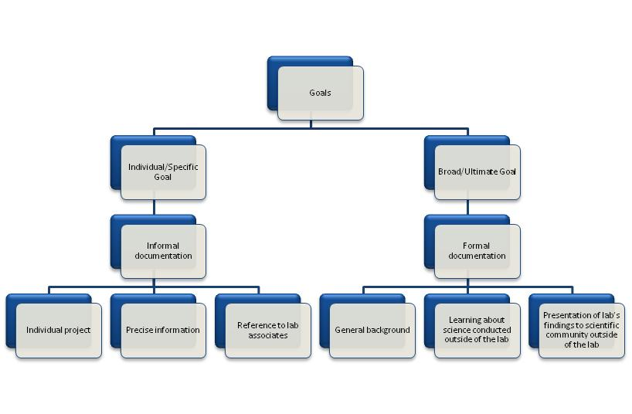
While, they are different in much of their linguistics, structure, and intent, both formal and informal documentation are vital to our lab. Formal documentation is both read and written in our lab. The formal documentation of other research is very useful when we need to obtain a grasp of general concepts regarding our research that is new to us. Also, all of our research is ultimately presented in a formal way—as a poster presentation in a conference or a published article in a scientific journal. The informal documentation is vital to a researcher’s organization in the lab and to his lab associates’ general understanding of the specific procedures and results of his experiments. The lab’s individualized practices and the sight of its ultimate goal are both maintained by utilizing both the informal documents that assist in its specific goals and the formal documents that grasp the broader goals. I have already begun my personal experience in research which I currently document informally and hope that in the next few years, I will be able to formally document an individual project that could be presented at a conference or perhaps even get published.

Works Cited
Cen, Shan, et al. "Incorporation of Lysyl-tRNA Synthetase into Human Immunodeficiency Virus Type 1." Journal of Virology 75.11 (2001): 5043-48. Print.
Senior Undergraduate Mentor. Personal interview. 26 Sept. 2013.
Sundaram, Sruthi. Research Notebook. 2013. MS. UC Chemistry Laboratory 708 & 709, Cincinnati.

Appendix
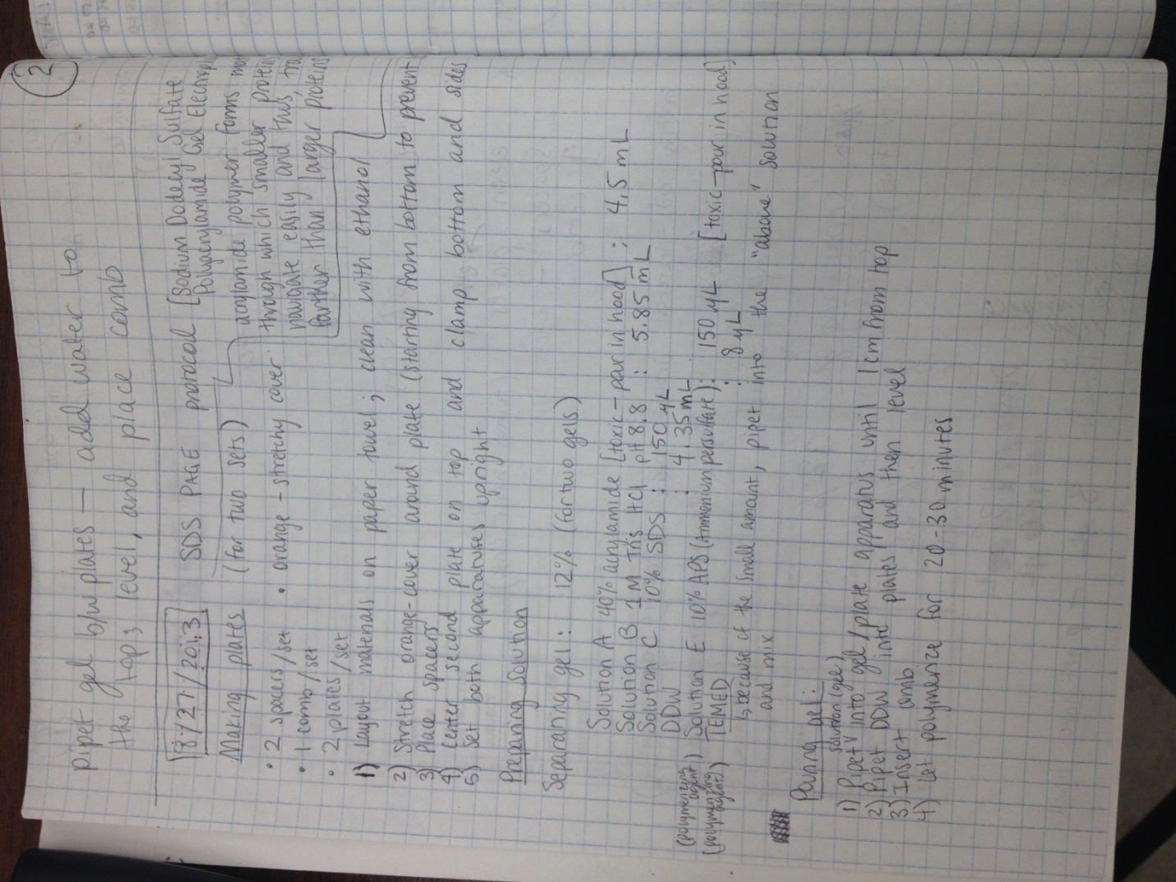

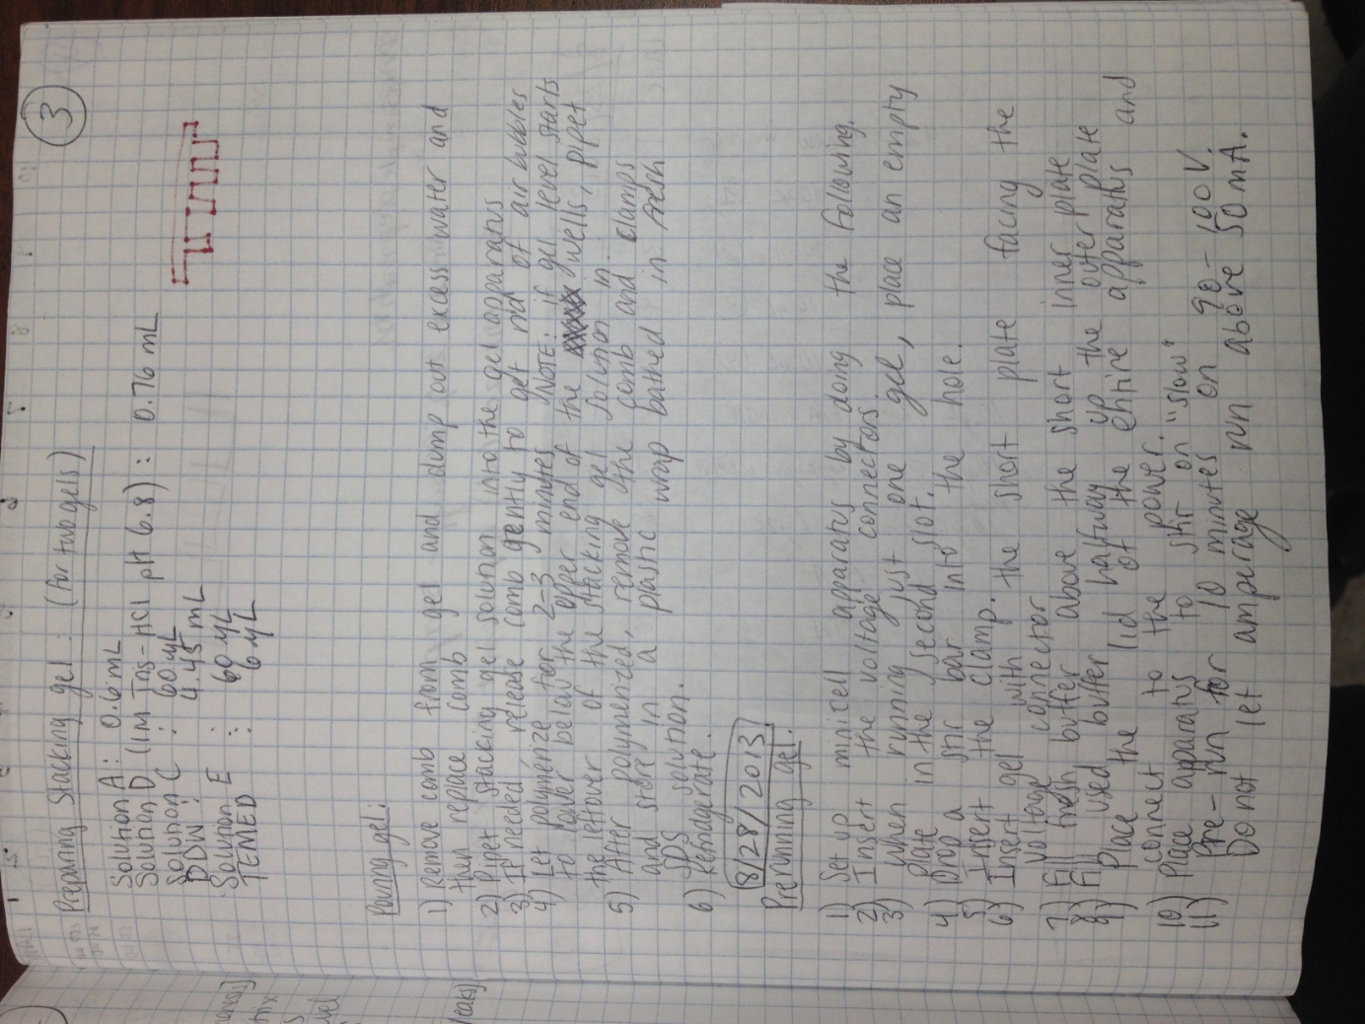
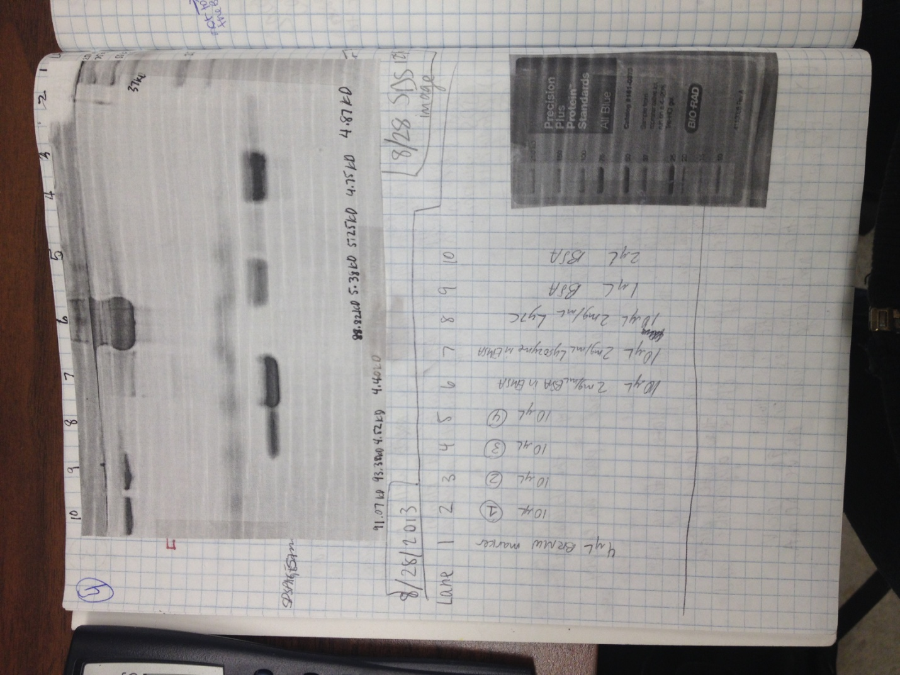
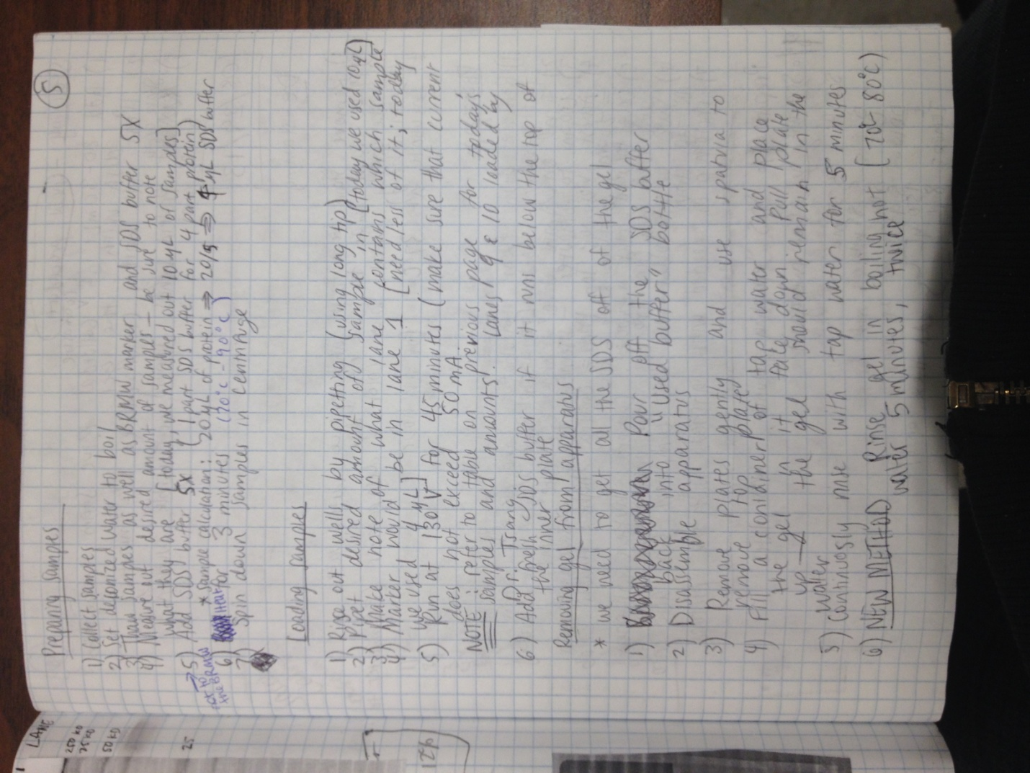
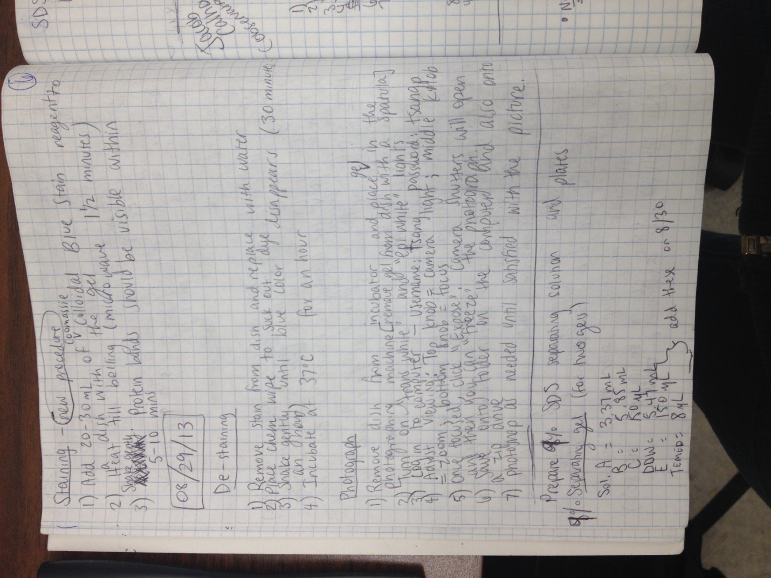
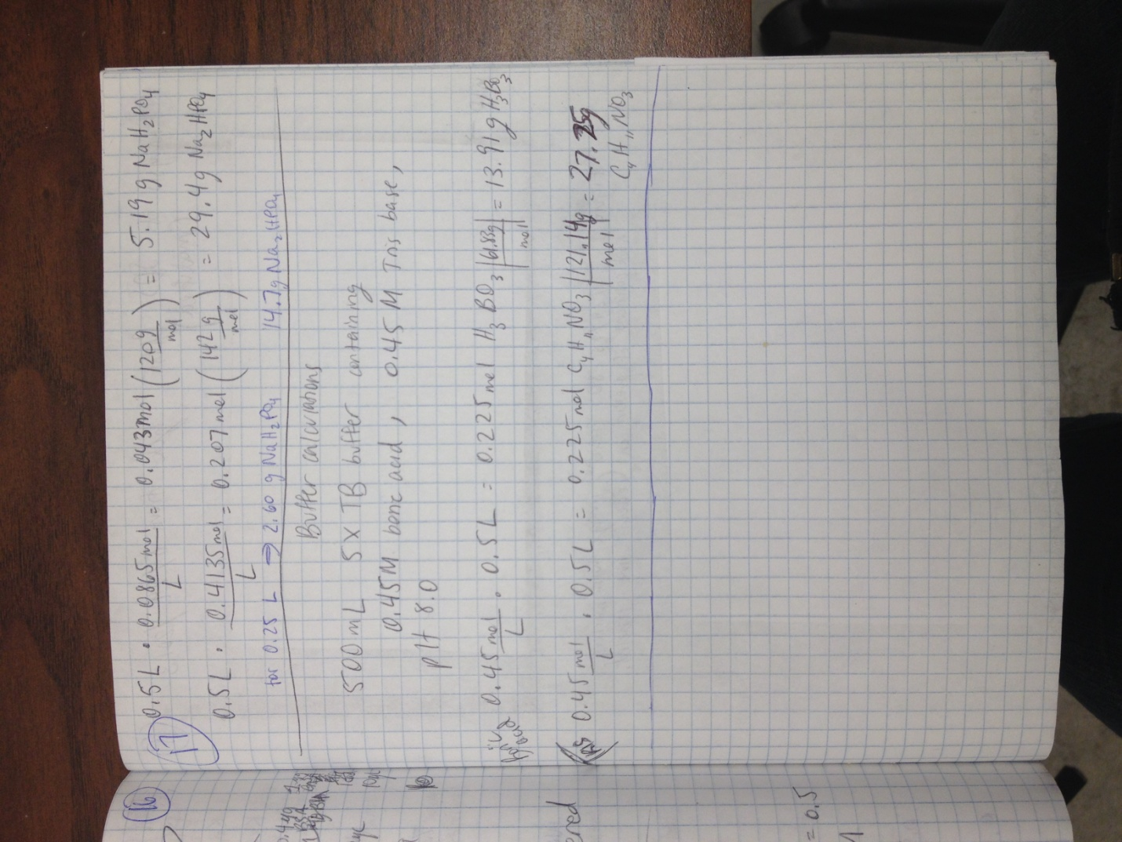
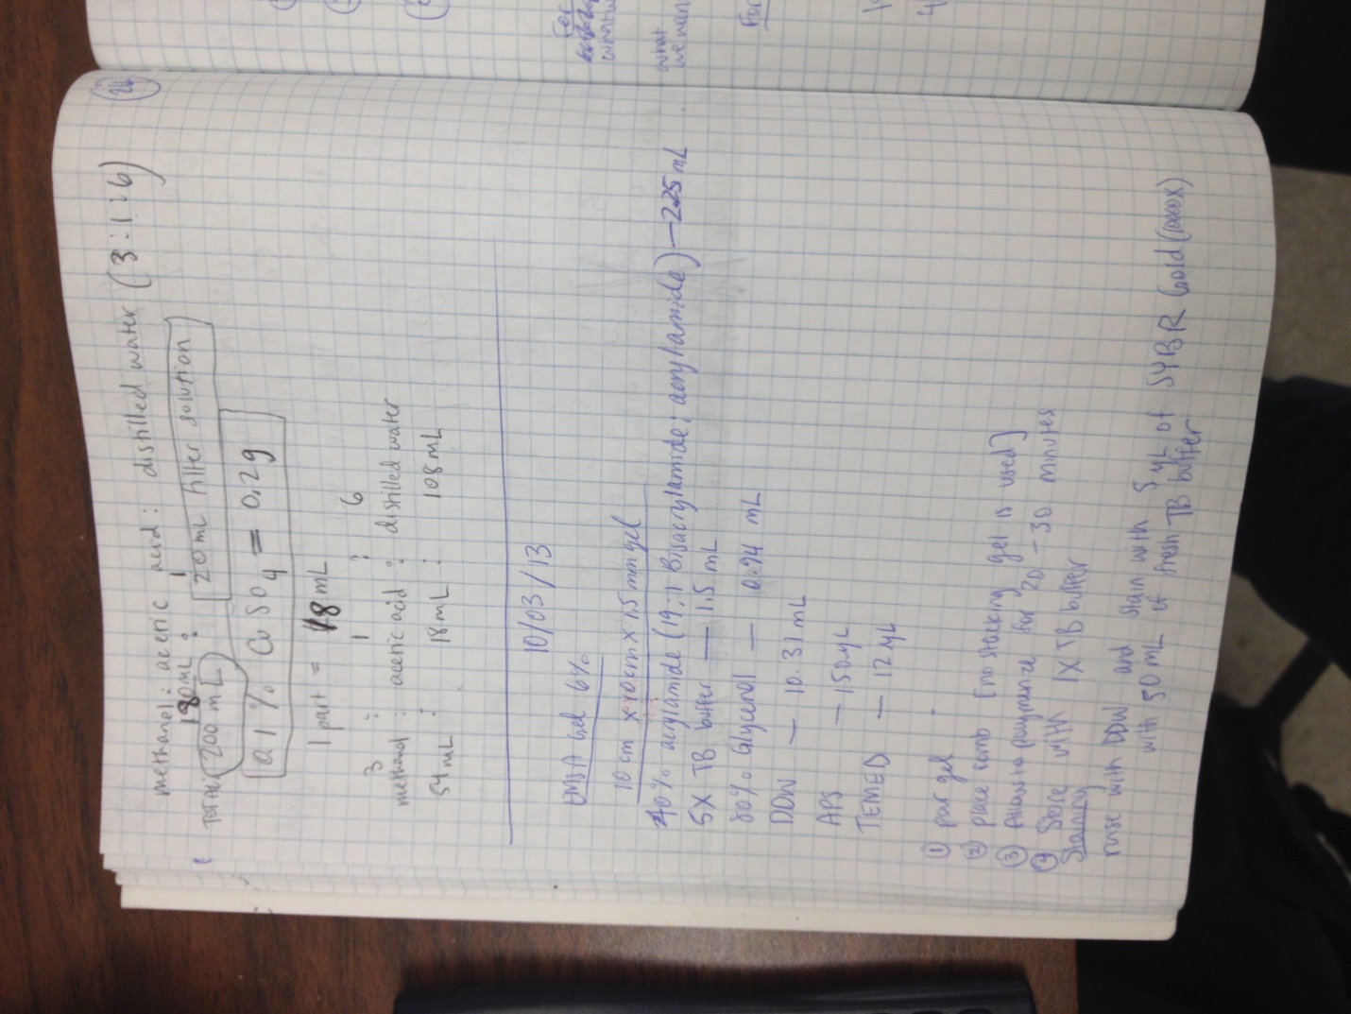
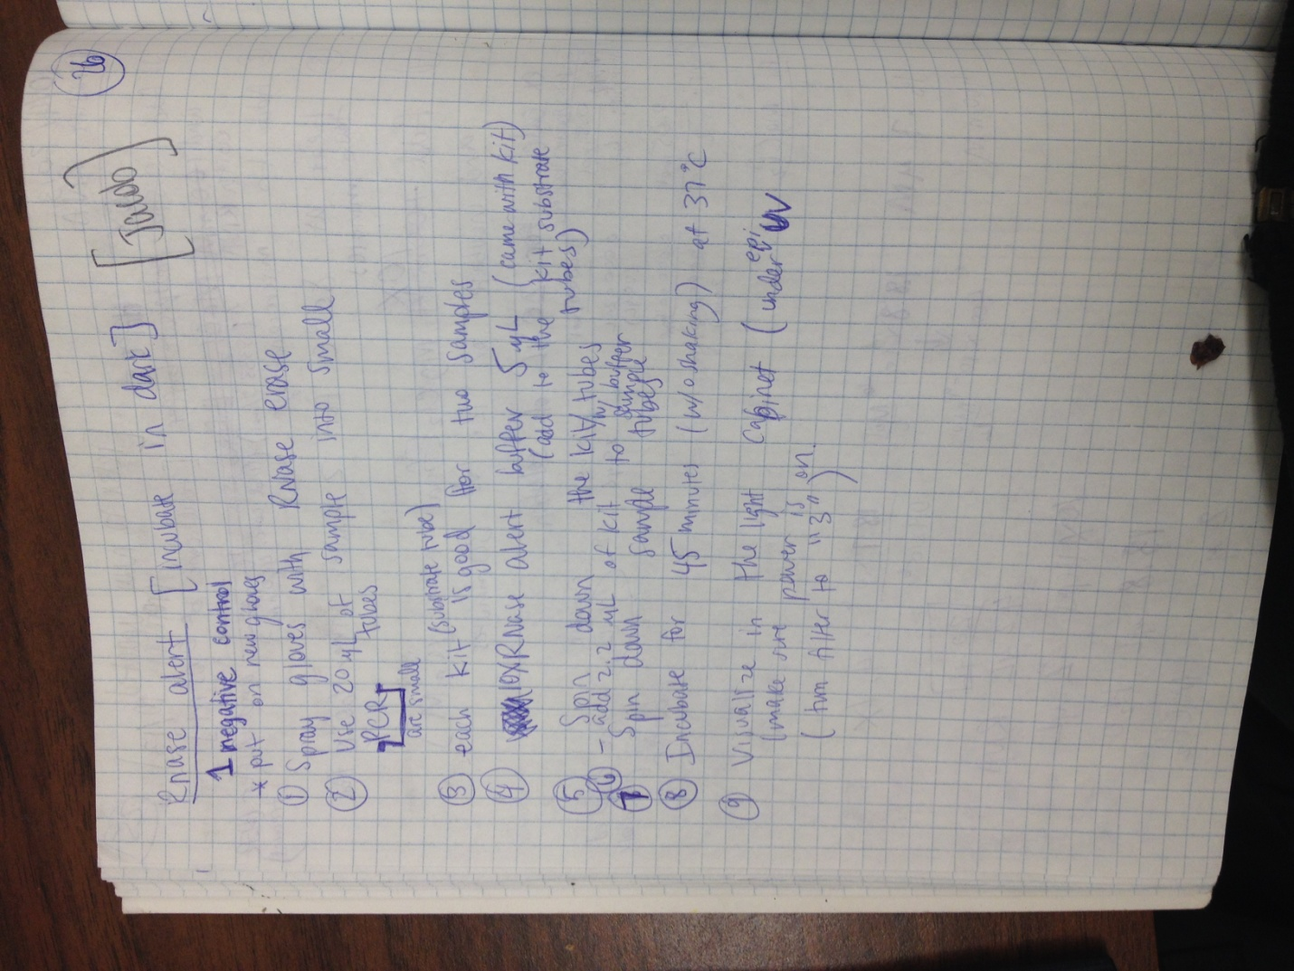

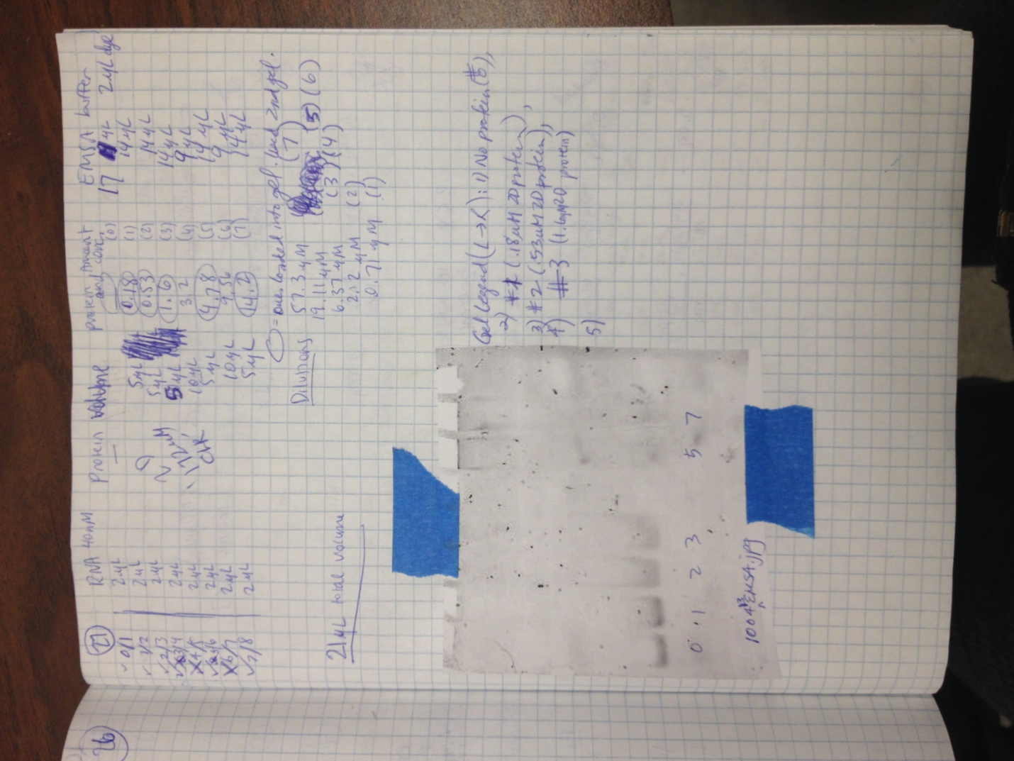
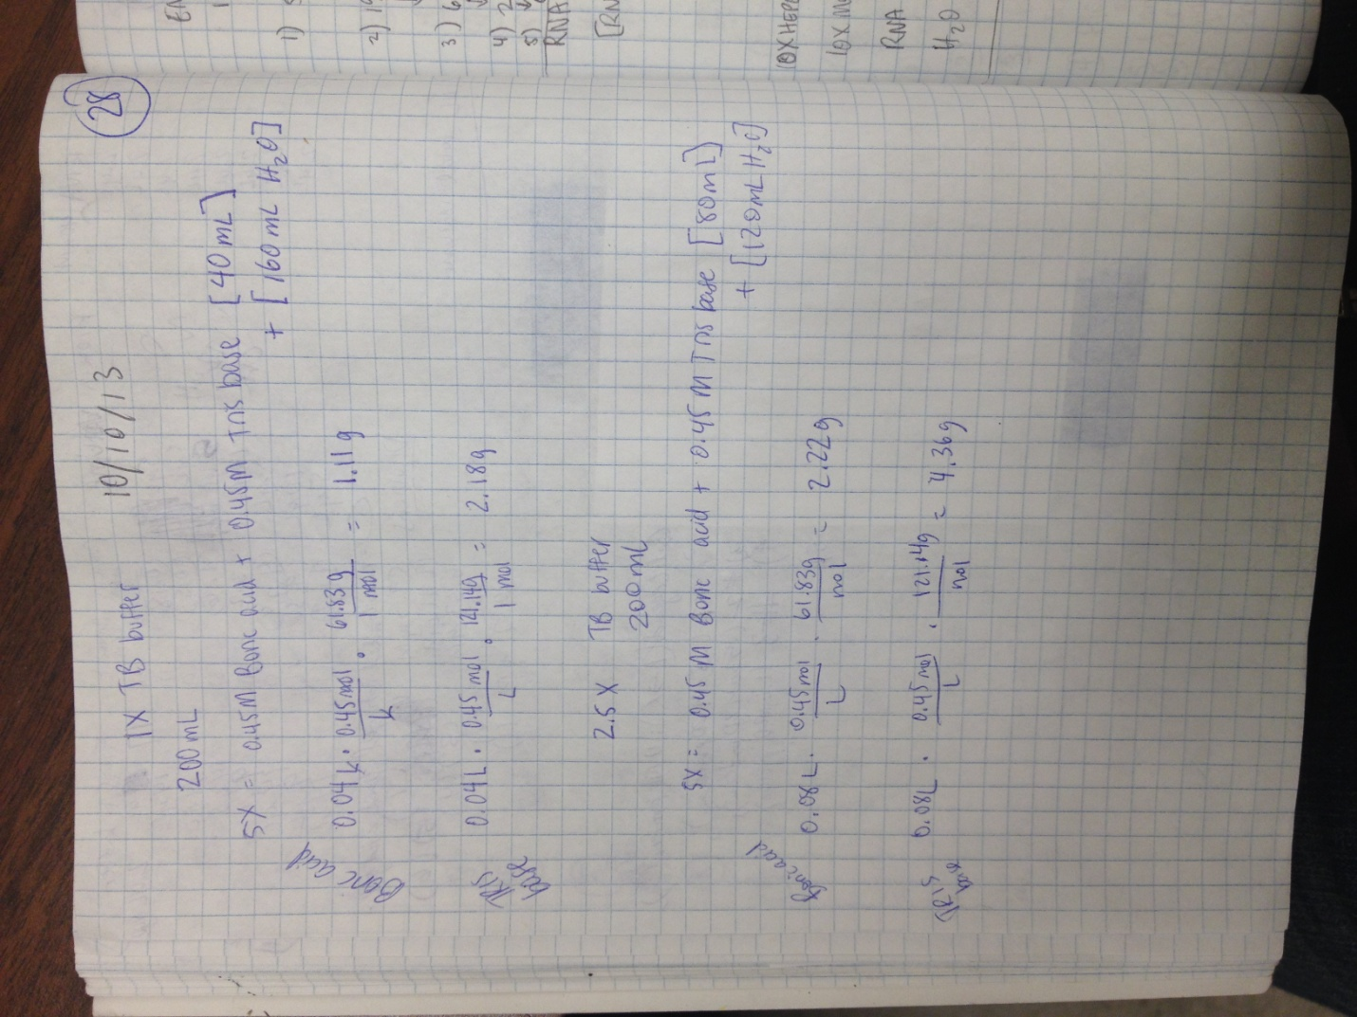
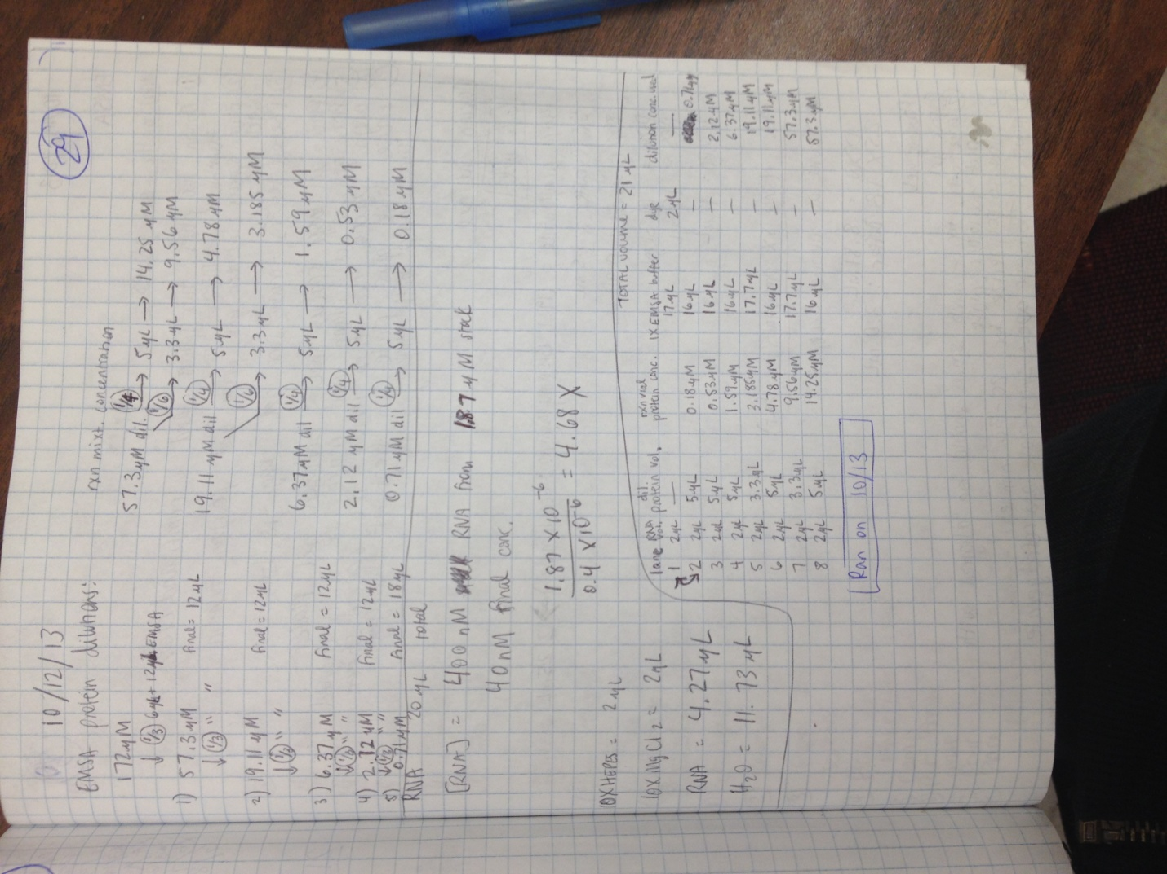
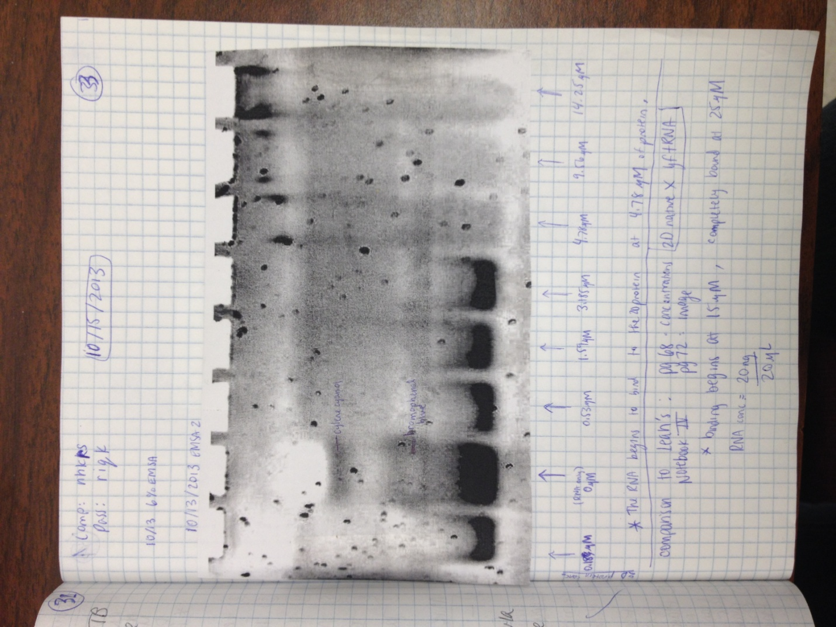

LysRS-HIV1 article.pdf ---attached separately with EMAIL

